Year 2 Autumn Term Curriculum Plan
English | Maths | Science | PSHE and RSE (Jigsaw)
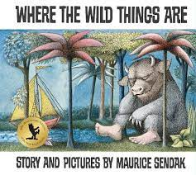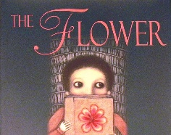  The children will learn:  - Story structure and language  - & rhymes:  - To read with fluency  - To read all of the 1st 100 high frequency words  Tto Identify the meaning of story vocabulary in context.  - To Use different voice pitch to indicate whether they are reading an exclamation or question  - To Use different voices for different characters  - To make simple inferences about a character’s actions.  - To predict the events of a story and action’s of a character  - To plan and write a story | 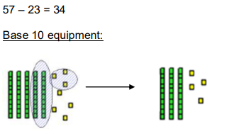  The children will learn:  - Will rapidly recall number facts to 20  - To understand place value of 2 digit numbers  - To Regroup 2 digit numbers  - To Order and compare 1 and 2 digit numbers  - To Estimate to help find the accurate answer to a claculation  - To know mental addition and subtraction using 1 and 2 digit numbers  - To find part of a whole number  - To use money to make different combinations of values and find change  - To order and compare different units of measure | Things I need!  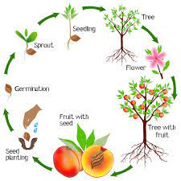  The children will learn:  - How seeds and bulbs grow into mature plants  - How plants need water, light and a suitable temperature to grow and stay healthy  - To identify and name a variety of plants  - To explore and compare the differences between things that are living, dead, and things that have never been alive  - About and describe the basic needs of animals, including humans, for survival  - About the importance for humans of exercise, eating the right amounts of different types of food, and hygiene  The children will work scientifically by:  - Observing, through video or first-hand  - how different animals, including humans, grow  - Asking questions about what things animals need for survival and what humans need to stay healthy  - Suggesting ways to find answers to questions.  Seasonal Change  - Observing Autumn and winter Weather and daily weather charts | Jigsaw Scheme  Being Me in My World and  Celebrating Difference  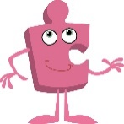  The children will learn:  - To recognise worried feelings & know who to ask for help  - The rights & responsibilities for being a member of class & school  - To contribute ideas about rewards & consequences  - To help make a class safe & fair  - To understand that there are stereotypes  - That people can be the same & different  - That bullying is sometimes about difference  - What is right & wrong & know how to look after myself  - When & how to stand up for myself & others  - How to get help if I am being bullied  - I understand differences make us all special    The children will learn:  - To identify a range of different emotions in themselves and others.  - To understand how behaviour effects them and how others see them  - How their body feels during different emotions  - To independently use tools & strategies to regulate emotions
History | Geography | Art and Design | Design and Technology
Mary Seacole and Florence Nightingale  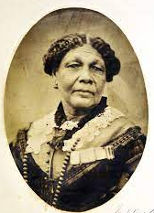  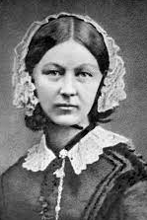  The children will learn:  - To understand that sources give us information about the past  - To know about Mary Seacole and her achievements  - To know the challenges Mary Seacole faced  - To know about Florence Nightingale and her achievements  - To know how both improved nursing | Extreme Weather  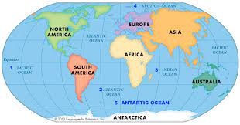  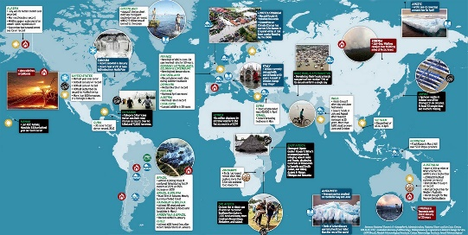  The children will learn:  - To name and locate the world’s seven continents and five oceans  - To identify the features of a climate for Europe and create a key  - To identify the features of a climate for Africa and create a key  - To identify the features of a climate for America’s and create a key  - To identify the features of a climate for Oceania and create a key  - To identify the features of a climate for Asia and create a key | Helen Frankenthaler and Henri Matisse  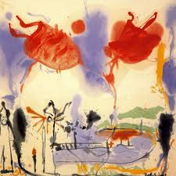  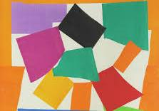  The children will learn:  - To know about great artists, craft makers and designers, and understand the historical and cultural development of their art forms.  - To compare artists work and their style and give their opinions.  - To produce creative work, exploring their ideas and recording their experiences  - To become proficient in drawing, painting, sculpture and other art, craft and design techniques  - To evaluate and analyse creative works using the language of art, craft and design | Food Technology  Super Salads  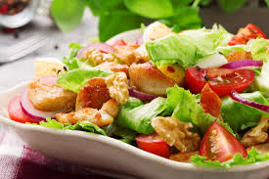  The children will learn:  - To understand where food comes from  - To know what foods are healthy  - Evaluate current salad packaging  - To have an understanding of health and safety and hygiene  - To use the safe cutting methods; bridge and claw  - To develop the skill of grating and snipping methods  - To use a brief to develop ideas to design a healthy salad  - To use the skills taught to make a healthy salad  - To evaluate the healthy salad against the design brief
Physical Education | Religious Education | Music | Computing
Football and Yoga  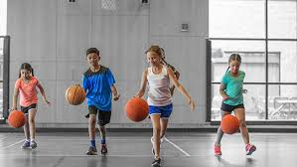  Children will learn:  - To develop skills in balancing, agility and coordination  - To apply these skills in a range of activities  - To develop skills in games which include simple tactics for attacking and defending  - To learn to co-operate and work in a team | Thankfulness, Light  and Christmas  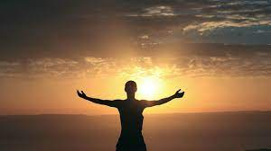  Children will learn:  - What makes some people important to us?  - Who has authority over me?  - Who is a Rabbi and why is they important in Judaism?  - Who is a vicar, and what does she or he do?  - Why do we need leaders?  - Who or what is God, if anything?  - What do people about God?  - What do people of different religions believe about God? Is Jesus God Incarnate?  - How can anyone know for sure whether or not ‘God’ exists? | Charanga Music Scheme  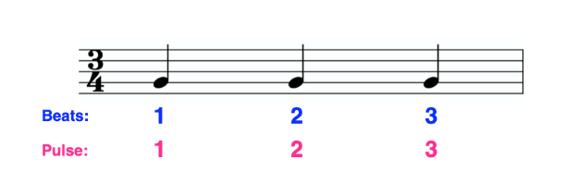  Children will learn:  - To identify pulse/beat within a piece of music  - To identify rhythm in a piece of music  - To identify pitch in a piece of music  - To be able to speak chants and sing a song in time to the beat | Technology around us and digital painting    Children will learn:  - To recognise the uses and features of information technology  - To identify the uses of information technology in the school  - To identify information technology beyond school  - To explain how information technology helps us  - To explain how to use information technology safely  - To recognise that choices are made when using information technology  - To use a digital device to take a photograph  - To make choices when taking a photograph  - To describe what makes a good photograph  - To decide how photographs can be improved  - To use tools to change an image  - To recognise that photos can be changed

