Year 1 Autumn Term Curriculum Plan
English | Maths | Science | PSHE and RSE (Jigsaw)
Handa’s Surprise  and Stickman  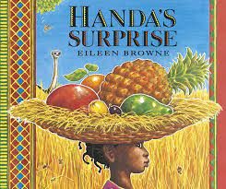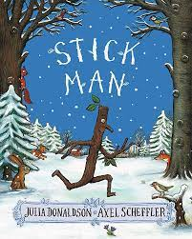  The children will learn:  - Story structure & rhymes  - stories including typical story language features  - Join in with predictable phrases in the story.  - Anticipate key likely events in the story.  - Explore and recall events from the story in order.  - Comments on things that interest them, links text content to own life experiences.  - Orally say simple sentence writing based on learned story  - Write simple sentences based on a learned story | Herts For Learning Essential Maths teaching Sequence  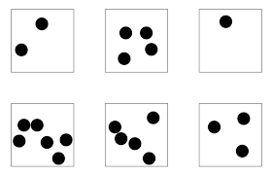  The children will learn:  - Counting to 100  - Mathematical language  - Positional Language  - Subitising numbers to 10  - Exploring numbers to 10  - Calculating within 10  - Exploring numbers to twenty  - Use mathematical equipment to explain strategies  - Shape - 2D and 3D | All about Me  And Best Material for an Umbrella  Seasonal CCHANGES  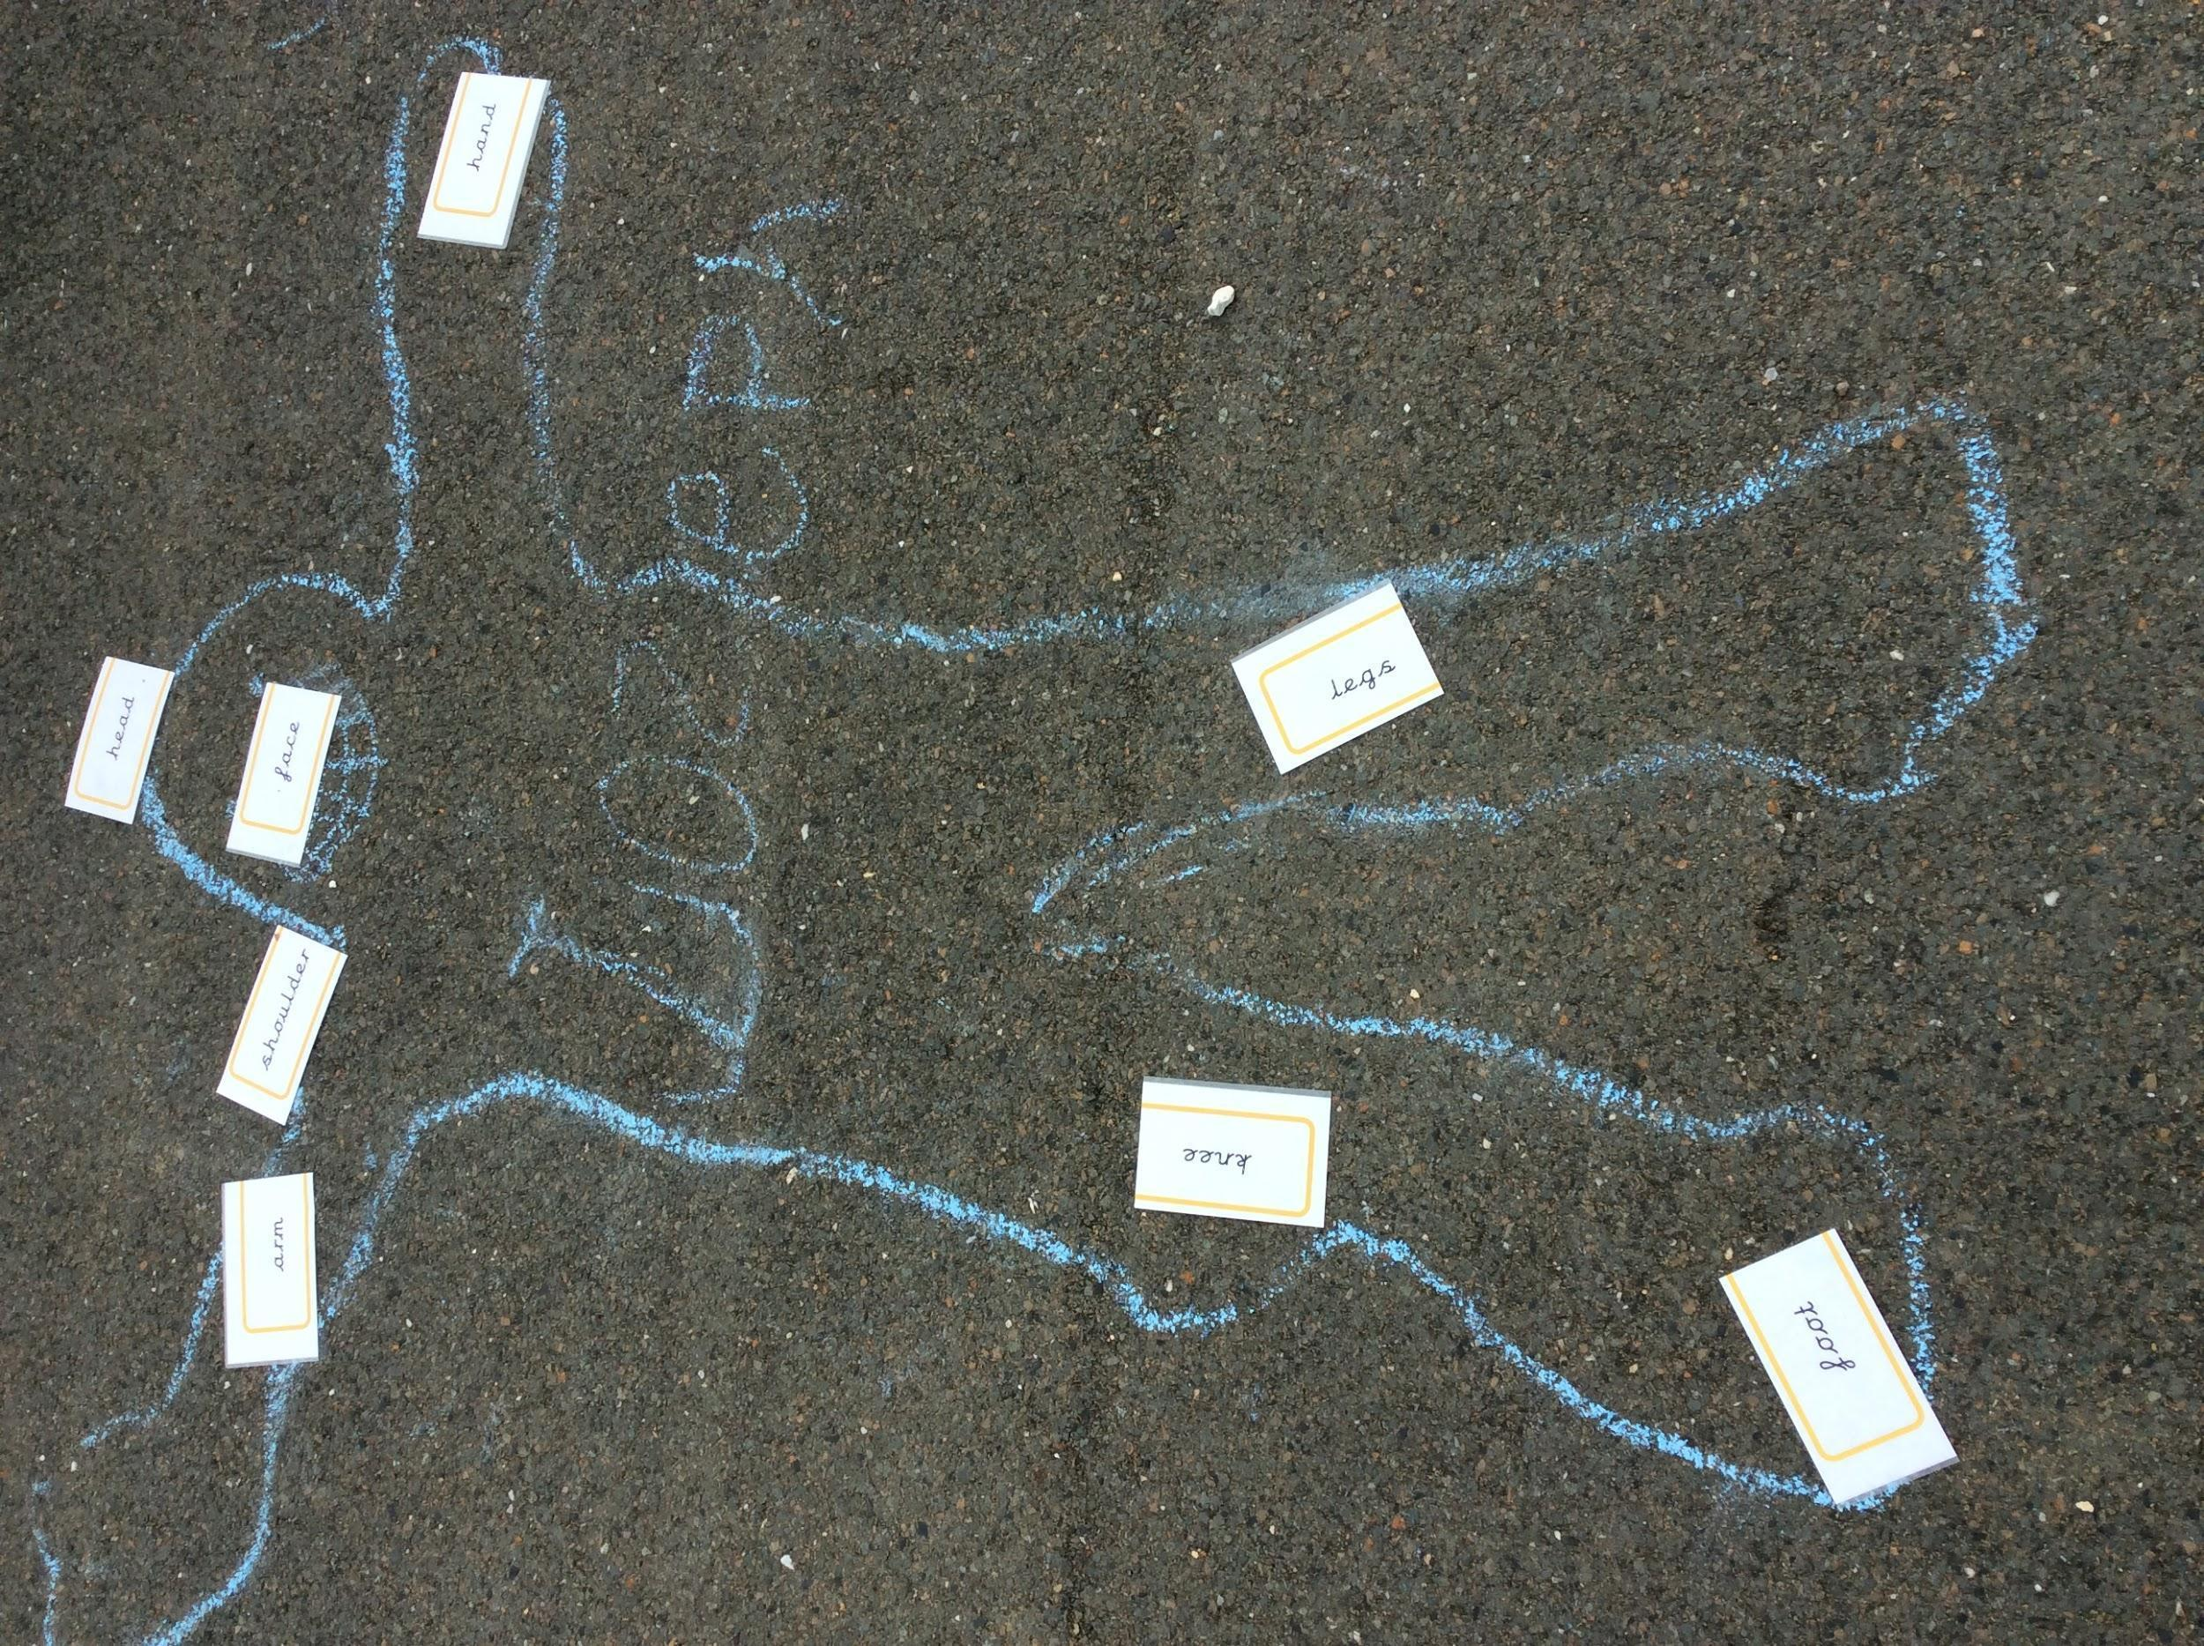  The children will learn:  All about Me  - To Identify, name, draw and label the basic parts of the human body  - To explain which part of the body is associated with each sense.  Working Scientifically:  - Children will use their senses to compare different textures, sounds, tastes and smells.  Materials  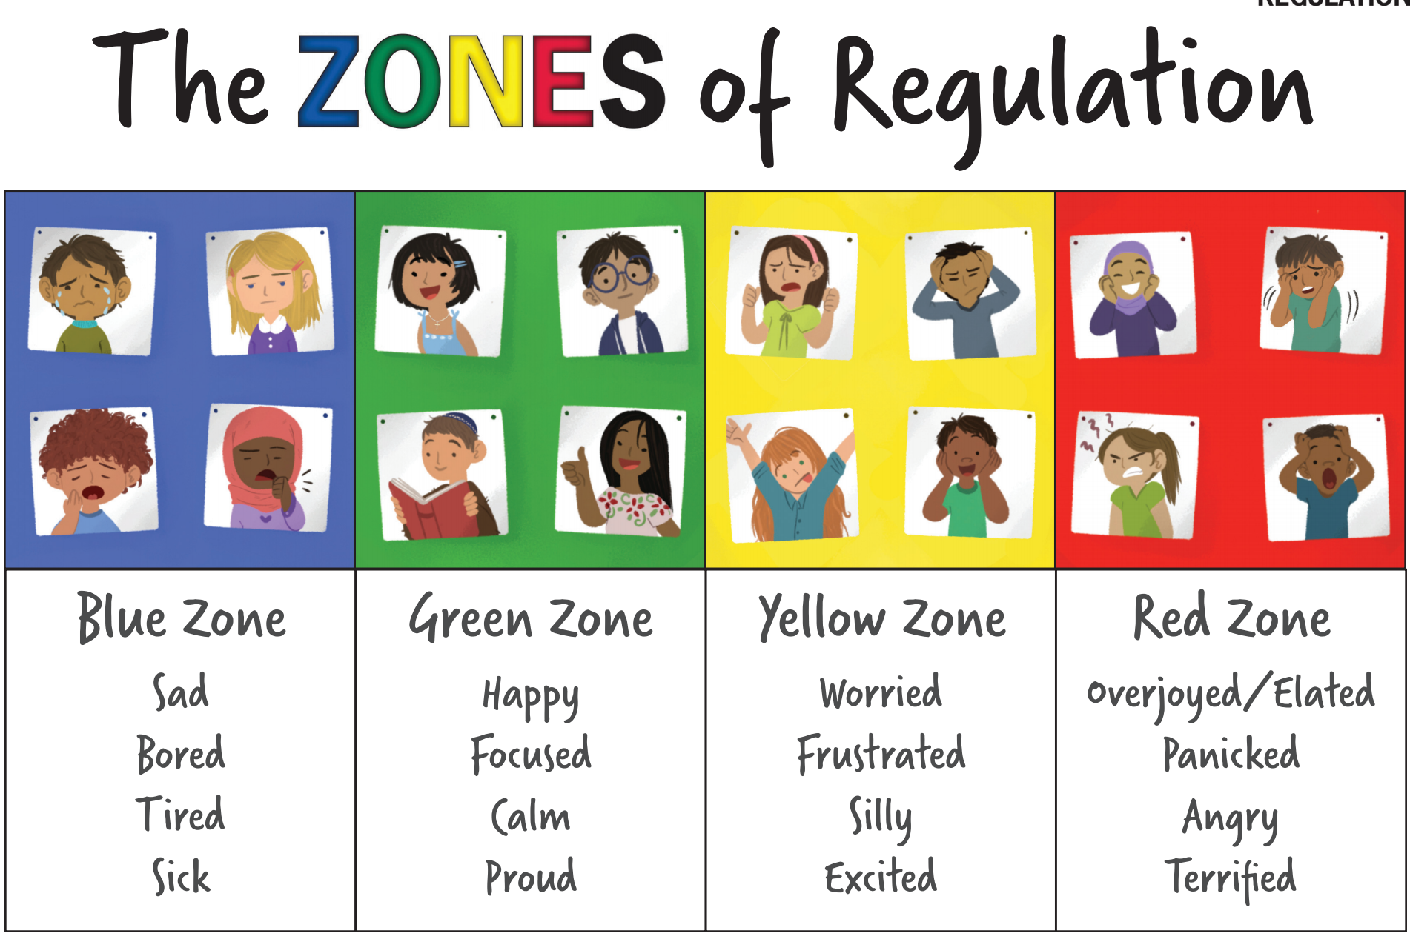  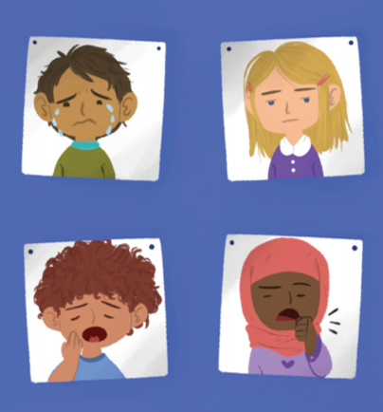  - To distinguish between an object and the material from which it is made  - To identify and name a variety of everyday materials, including wood, plastic, glass, metal, water, and rock  Working scientifically:  - Perform simple tests to explore questions e.g. what is the best material for an umbrella | Jigsaw Scheme  Being Me in My World and  Celebrating Difference  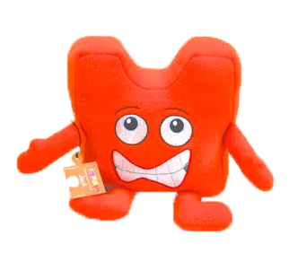  The children will learn:  - To feel special and safe  - To be part of a class  - Their rights and responsibilities  - About rewards and feeling proud  - About consequences  - About similarities and differences  - What bullying is and know how to deal with it  - About making new friends  - To celebrating the differences in everyone    The children will learn:  - To identify a range of emotions in themselves and others.  - About emotions impacting behaviour  - To regulate their emotions using different tools and strategies.
History | Geography | Art and Design | Design and Technology
Watford Old and New  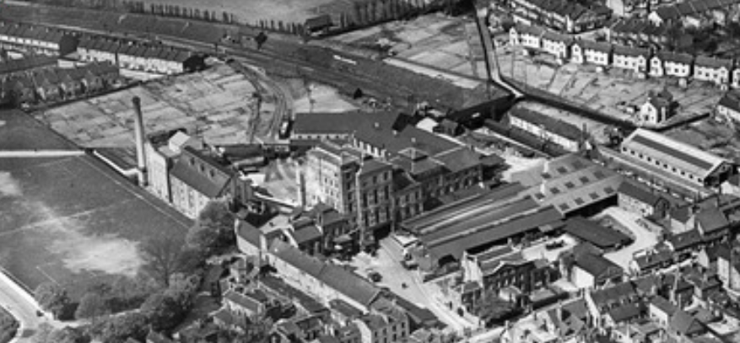  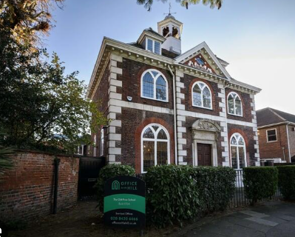  Children will learn:  - To know what our school was like before it was built  - To explore sources which show the past of Watford Fields  - To know that there are sources of historical importance  - To identify old and new buildings in Watford  - To know how the use of buildings can change over time | My Local Area  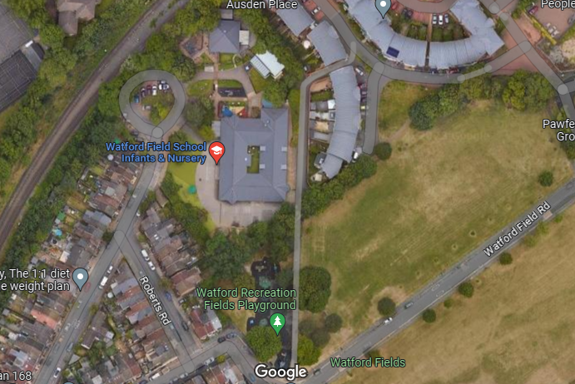  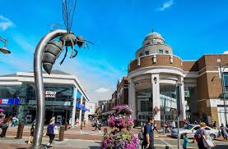  Children will learn:  - What an aerial viewpoint is (aerial shots of the school)  - To identify Watford on a map  - To identify Watford Fields on a map (draw a map)  - To identify the physical features of Watford on a map  - To identify the human features of Watford on a map | Piet Mondrian (1972-1944)- Dutch painter and Bridget Riley  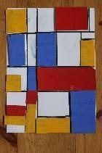  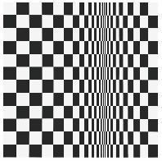  Children will learn:  - About the works of two artists and compare similarities and differences  - To express opinions on different art work  - To use drawing, line, shape and colour to develop ideas  - To experiment with lines and colour  - To create a final piece using developed skills of line and colour  - To self-evaluate | Food Technology  Fruit Smoothies  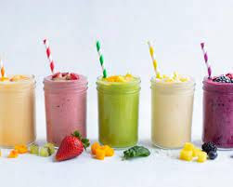  Children will learn:  - Where different fruits come from  - Taste different fruits  - Understand that fruits are healthy  - Identify different food types on the eat well plate  - Design a healthy smoothie  - The rules of health and safety whilst using kitchen utensils  - The importance of hygiene  - Techniques in cutting and grating fruit safely  - To create a smoothies  - To self-evaluate
Physical Education | Religious Education | Music | Computing
Ball skills and Yoga  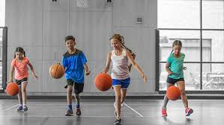  Children will learn:  - To develop skills in balancing, agility and coordination  - To apply these skills in a range of activities  - To develop skills in games which include simple tactics for attacking and defending  - To learn to co-operate and work in a team | Thankfulness, Light  and Christmas  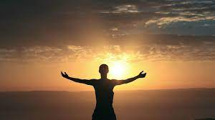  Children will learn:  - To identify how people give thanks  - To learn about how different have different festivals and celebrations that give thanks (Sukkot - Judaism and Harvest - Christianity)  - To identify the importance of light in everyday lives  - To know that Diwali is an important celebration in Hinduism and how it is celebrated  - To identify how light is represented through symbols in different religions like Christianity and Hinduism  - To identify why Christmas is important to Christians through learning about the Nativity | Charanga Music Scheme  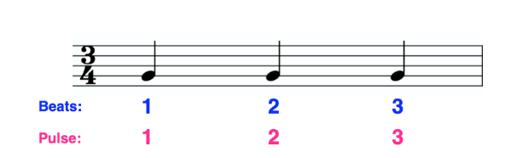  Children will learn:  - To identify pulse/beat within a piece of music  - To identify rhythm in a piece of music  - To identify pitch in a piece of music  - To be able to speak chants and sing a song in time to the beat  - To explain how a piece of music can make me feel | Technology around us and digital painting    Children will learn:  - How to login to Chromebooks,  - How to use them including the mouse and keyboard  - To understanding what technology is  - To identify parts of a computer  - To create rules for using technology safely and responsibly at school and beyond, as well as being happy  - The importance of passwords

